Hadoop 3.1.4 Configuration & Commands

Installation in Windows 10

Download Java JDK8 & Hadoop 3.1.4:
https://medium.com/analytics-vidhya/hadoop-on-windows-eb322f520168
https://youtu.be/knAS0w-jiUk?si=9wbqiSroXBPZUtXc
https://youtu.be/GfixwKmS8Ro?si=SfIOECrJrauW7YIC

To run wordcount program on Hadoop & Yarn, follow this link:
https://youtu.be/nsi4nVS16lc?si=K3G3nGo_T-SC6SME

Setting up Java8 and Hadoop 3.1.4:
Download Java8 and Hadoop 3.1.4 and edit the environment variables for the Windows user (in this case it is Admin) and it should look like this:
Note: No space allowed in the folder name

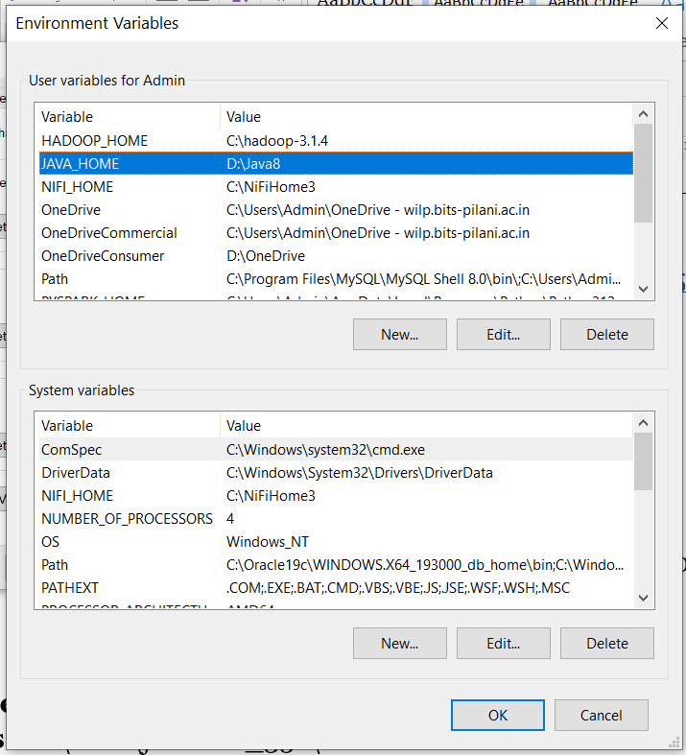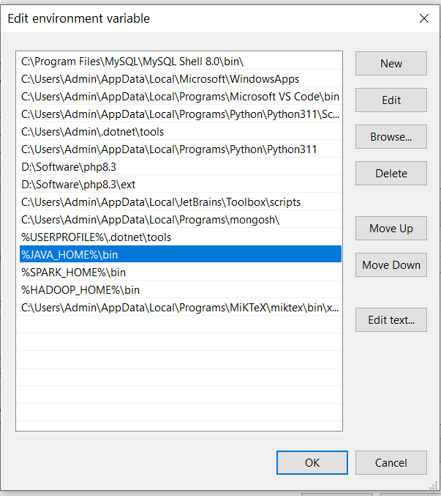

Hadoop home is : C:\hadoop-3.1.4
Java Home is : D:\Java8
Make sure to edit Path variables for Java and Hadoop (\bin is mandatory.)

Go to C:\hadoop-3.1.4\etc\hadoop
1. core-site.xml
<configuration>
<property>
<name>fs.defaultFS</name>
<value>hdfs://localhost:9000</value>
</property>
</configuration>
2. mapred-site.xml
<configuration>
<property>
<name>mapreduce.framewwork.name</name>
<value>yarn</value>
</property>
</configuration>

3. Create a folder 'data' in Hadoop home C:\hadoop-3.1.4\data and 'namenode' and 'datanode' folders under data. Edit hdfs-site.xml
<configuration>
<property>
<name> dfs.replication</name>
<value>1</value>
</property>
<property>
<name>dfs.namenode.name.dir</name>
<value>C:\hadoop-3.1.4\data\namenode</value>
</property>
<property>
<name>dfs.datanode.data.dir</name>
<value>C:\hadoop-3.1.4\data\datanode</value>
</property>
</configuration>

4. yarn-site.xml
<configuration>
<!-- Site specific YARN configuration properties -->
<property>
<name>yarn.nodemanager.aux-services</name>
<value>mapreduce_shuffle</value>
</property>
<property>
<name>yarn.nodemanager.auxservices.mapreduce.shuffle.class</name>
<value>org.apache.hadoop.mapred.ShuffleHandler</value>
</property>
</configuration>

5. hadoop-env.cmd
Replace JAVA_HOME with JAVA_HOME= D:\Java8\bin

Commands:
1. Before executing any command in HDFS, execute the following in cmd prompt:
C:\Users\Admin>hadoop version
You should get:

Hadoop 3.1.4
Source code repository https://github.com/apache/hadoop.git -r 1e877761e8dadd71effef30e592368f7fe66a61b
Compiled by gabota on 2020-07-21T08:05Z
Compiled with protoc 2.5.0
From source with checksum 38405c63945c88fdf7a6fe391494799b
This command was run using /C:/hadoop-3.1.4/share/hadoop/common/hadoop-common-3.1.4.jar

2. Format the namenode:
c:\hadoop-3.1.4\sbin>hdfs namenode -format

3. Starting Hadoop HDFS:
c:\hadoop-3.1.4\sbin>start-dfs

4. Starting YARN:
c:\hadoop\sbin>start-yarn

5. Check the status:
c:\ hadoop-3.1.4\sbin>jps
13712 ResourceManager
12452 NodeManager
15316 Jps
868 NameNode
13560 DataNode

6. Create a directory called user:
c:\hadoop-3.1.4\sbin>hdfs dfs -mkdir /user

7. Copy the file Hello.java from local drive to /user and display the file:
c:\hadoop-3.1.4\sbin>hdfs dfs -copyFromLocal D:\Hello.java /user

c:\hadoop\sbin>hdfs dfs -cat /user/Hello.java
/* First Java program to say Hello */
public class Hello { // Save as "Hello.java" under "d:\myProject"
public static void main(String[] args) {
System.out.println("Hello, world!");
}
}

8. List Files in /user directory
c:\hadoop-3.1.4\sbin>hdfs dfs -ls /user
Found 1 items
-rw-r--r-- 1 Admin supergroup 210 2024-08-10 10:47 /user/Hello.java

9. Wordcount Program Demo
(a) Create a directory /input
c:\hadoop-3.1.4\sbin>hdfs dfs -mkdir /input
Create data.txt
Hello
California
Scott
Hello
Iceland
Nandagopalan
California
Scott
India
America

(b) Copy the input data.txt file to /input folder
c:\hadoop-3.1.4\sbin>hdfs dfs -copyFromLocal D:\WordCountTutorial\InputData\data.txt /input

(c) Create a directory /out
c:\hadoop-3.1.4\sbin>hdfs dfs -mkdir /out

(d) Execute the mapreduce jar file located in the Hadoop/share folder and store the result in /out folder
c:\hadoop-3.1.4\sbin>hadoop jar C:/Hadoop-3.1.4/share/hadoop/mapreduce/hadoop-mapreduce-examples-3.1.4.jar wordcount /input /out

(e) Output files in /out folder:
c:\hadoop-3.1.4\sbin>hdfs dfs -ls /out
Found 2 items
-rw-r--r-- 1 Admin supergroup 0 2024-08-10 14:44 /out/_SUCCESS
-rw-r--r-- 1 Admin supergroup 72 2024-08-10 14:44 /out/part-r-00000

(f) Display the Result
c:\hadoop-3.1.4\sbin>hdfs dfs -cat /out/*
America 1
California 2
Hello 2
Iceland 1
India 1
Nandagopalan 1
Scott 2

You can verify the presence of output file in the HDFS dashboard by visiting http://localhost:9870 and navigate to Utilities section.

For more details on creating and executing mapreduce java programs, click:
https://medium.com/@tirthshah100/word-count-in-apache-hadoop-mapreduce-c6ee8e737fb9

